ComMOCSvc service extension for file processing
GEA Image Extractor
Conception Document

Reference : |  |  |  | Revision : |  | Date : | 29/10/2003
Verified by: |  |  | Date : |  |  | Visa :
Approved by: |  |  | Date : |  |  | Visa :
Author : | T. Cvitanic
Project Name : |  | HAC
Project Redo :
Diffusion list:

HISTORY EVOLUTION

Version | Date | Evolution | Author
A | 29.10.2003 | Creation | TC

TABLE OF CONTENTS

1. Introduction 4
1.1. Document presentation 4
1.2. Glossary 4
1.3. Referent documents 5
2. MODULE PrEsentation 6
2.1. Functional diagram 6
2.2. Module parameters 8
2.3. File processing 9
2.3.1. File naming convention and the subdirectory tree 9
2.3.2. File backup 9
2.3.3. Files deletion 10

Introduction

Document presentation
The purpose of this document is to describe the ComMOCSvc service extension module that extracts the picture form the GEA image file.
The module contains three exported functions that are described in the "Dossier de conception de CommocSvc.doc" document. The ComMOCSvc service uses these three functions to initiate the module, process detected file and close the module.

Glossary
MOC Central system
GEA Grenobloise d’Electronique et d’Automatismes

Referent documents
Dossier de conception de CommocSvc.doc | Revision: B
Manuel de maintenance de CommocSvc.doc | Revision: B

MODULE PrEsentation
The GEA image file consists of:
- header that contains the information about the transaction and picture
- one or two pictures in the JPG format
The GEA image extractor module detects how many pictures are stored in the GEA image file. It extracts the pictures and stores them into the file in the appropriate directory. The file naming convention and the directory tree structure will be explained in the next document sections.

Functional diagram
The module uses five directories for the file processing. The "Mail In" directory contains the GEA image files that have to be processed. As soon as the ComMOCSvc service detects the new file in the "Mail In" directory it calls the WorkerProcessFile function. This function first extracts the GEA image file header that contains the information related to the image (where the image is acquired, when it is acquired, why it is acquired etc.). Also, the header file contains the information of how many pictures are stored in the file (one or two) and size of the first picture. Using this information the module extracts the picture or pictures form the file and stores them into the "Out" directory. If the picture is successfully extracted and stored in the file, the original GEA image file will be moved to the "Backup" directory. If the file processing is not successful the GEA image file will be moved to the "Error" directory. The "Mail In Ack" directory is module generic directory that ComMOCSvc service uses to store processed files. Since the processed file is moved to the "Backup" or "Error" directory after processing the ComMOCSvc service can't move it to the "Mail In Ack" directory. Thus, this directory remains always empty.
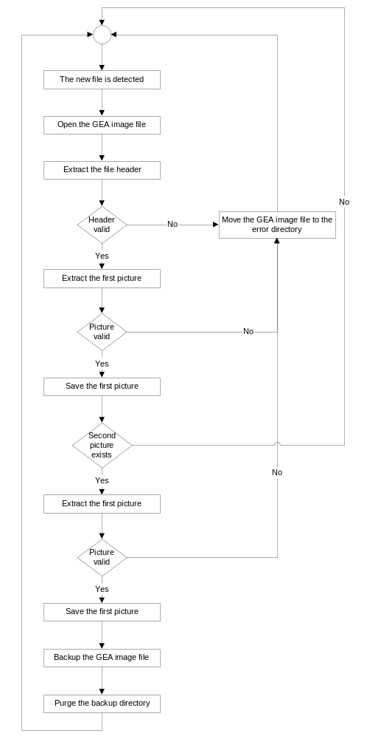

Module parameters
The module parameters are stored under the HKEY_LOCAL_MACHINE\System\CurrentControlSet\Services\CommocSvc\Parameters\Workers\ModuleName registry key where the ModuleName can be any string. It means that the user can start many instances of the module and he can give them different names (and adjust different parameters).

Module registry parameters description
Variable name | Variable type | Description
Dll | String | csr_cmworkgeaimg.dll – the name of the library from which the ComMOCSvc service will call the module functions.
PollingPeriod | Dword | This parameter adjusts the time between two directory checking (in milliseconds).
TraceFile | String | Name of the module trace file.
LocalMailIn | String | This is the directory where the GEA image files are stored. The ComMOCSvc service checks this directory to detect if there is any new file to process.
LocalMailInAck | String | Not used
OutDirectory | String | This is the directory where the successfully extracted pictures are stored.
BackDirectory | String | Successfully processed GEA image files are stored in this directory.
ErrDirectory | String | Unsuccessfully processed GEA image files are stored in this directory.
MaxBakTries | Dword | This number defines how many times the module will try to move file to the backup directory. After maximal number of unsuccessful tries the module cancels the file moving.
MaxBakFiles | Dword | Maximal number of files stored in the backup directory.
MaxBakCumulFileSize | Dword | Maximal cumulative file size in the backup directory (in bytes). If it is zero the module doesn't check the cumulative file size.

File processing

File naming convention and the subdirectory tree
Using the data from the GEA image file header the module creates the file name and subdirectory in which the image will be stored. All the extracted images are stored in the "Out" directory (defined in the module parameters) and subdirectory defined by the lane name from the image header file. The file name has following format:
PPPPLLLYYYYMMDDHHMISEJJTTTTTI.JPG

- PPPP is plaza number
- LLL is lane number
- YYYY is year of the image acquisition (trs. generation)
- MM is month of the image acquisition (trs. generation)
- DD is day of the image acquisition (trs. generation)
- HH is hour of the image acquisition (trs. generation)
- MI is minute of the image acquisition (trs. generation)
- SE is second of the image acquisition (trs. generation)
- JJ is job number
- TTTTT is transaction number
- I is picture index

File backup
After the GEA image file is successfully processed it is moved to backup directory. During it's moving the module rename the file by adding the "YYYYMMDDHHMISE." prefix. The fields are described above. If the file moving is unsuccessful the module tries to copy it as many times as it is defined in the module parameters. If the number of unsuccessful tries is reached the file will not be moved to the backup directory. In this case it will remain in the "Mail In" directory or ComMOCSvc service will copy it to the "Mail In Ack" directory.

Files deletion
After the file backup, the module checks if it is necessary to delete any file from the backup directory. There are two parameters that determine the purging of the backup directory. The MaxBakFiles parameter determines how many files can be stored in the backup directory. If the number of files stored in the backup directory is greater than the MaxBakFiles parameter the module will delete unnecessary files (the oldest files). After the module has checked the number of files stored in the backup directory it checks the cumulative size of the remaining files. If the cumulative size is greater than the MaxBakCumulFileSize parameter the module will be deleting the files until their cumulative size is greater than the maximal allowed cumulative size. If the MaxBakCumulFileSize parameter is equal to zero the module will not check the cumulative size.

